**Product: Robinhood**

CONFIDENTIAL

Not for use in any form without the explicit written permission from Beningo Engineering.

|  |  |  |  |
| --- | --- | --- | --- |
| **Approval List** | | | |
| **Prepared by:** | Jacob Beningo | | **Date:** 03-04-2014 |
| **Approved by:** | Jacob Beningo | | **Date:** 03-04-2014 |
| **Approved by:** |  | | **Date:** |
| **Approved by:** |  | | **Date:** |
| **Approved by:** |  | | **Date:** |
| **Release Date:** | 03-04-2014 | **Current Release Version: 1.0** | See Revision History |

**REVISION HISTORY:**

|  |  |  |  |
| --- | --- | --- | --- |
| **Revision:** | **Description of Changes:** | **Date:** | **Revision By:** |
| 1.0 | Document Release | 03.04.2014 | JWB |
|  |  |  |  |
|  |  |  |  |
|  |  |  |  |
|  |  |  |  |
|  |  |  |  |
|  |  |  |  |
|  |  |  |  |
|  |  |  |  |

**REFERENCES:**

|  |  |  |
| --- | --- | --- |
| **Revision:** | **Document:** | **Author:** |
| 1.0 | Panda5AJ.1.5.1 Release Notes | Texas Instruments |
|  |  |  |
|  |  |  |
|  |  |  |
|  |  |  |
|  |  |  |
|  |  |  |
|  |  |  |
|  |  |  |

Table of Contents

1. Situation Appraisal 2

2. Objectives 3

3. USBBOOT 3

4. Fastboot 3

5. Adding Google Applications 3

6. Keeping the Display from Sleeping 4

7. Setting up SPAN 5

1. **Situation Appraisal**

Setting up the build environment for Android on the OMAP5 is not a trivial process. There are a number of steps in addition to a couple of issues related to exactly following the 5AJ1.5.1 release notes from Texas Instruments. This document walks through each and every step that is necessary to setup a build environment on Ubuntu 12.04 LTS 64-bit.

1. **Objectives**

The objective of this document is to:

* Explain how to setup the build environment
* How to build Android and the kernel for the first time
* How to setup build scripts for future builds of the operating system

1. **PC Packages Setup**

There are a number of packages that need to be installed on the pc in order to compile the kernel. Following the TI and Android setup instructions can result in installing packages that will cause a graphics issue and cause the pc to display to show nothing when booting. These steps should be followed exactly!

$ sudo apt-get install git-core flex bison gperf libesd0-dev zip libwxgtk2.8-dev zlib1g-dev build-essential tofrodos

$ sudo apt-get install lib32readline6-dev libstdc++6 lib32z1 lib32z1-dev ia32-libs g++-multilib libx11-dev libncurses5-dev

$ sudo apt-get install uboot-mkimage libxml2-utils

$ sudo apt-get install git gnupg flex bison gperf build-essential \

zip curl libc6-dev libncurses5-dev:i386 x11proto-core-dev \

libgl1-mesa-dev g++-multilib mingw32 tofrodos \

python-markdown libxml2-utils xsltproc zlib1g-dev:i386

$ sudo ln -s /usr/lib/i386-linux-gnu/mesa/libGL.so.1 /usr/lib/i386-linux-gnu/libGL.so

DO NOT INSTALL THE FOLLOWING:

libx11-dev:i386 libreadline6-dev:i386 libgl1-mesa-glx:i386

1. **PC Java Installation**

This version of Android can only be built using the oracle version of Java. Java 6 has to be used and the last version of which is release 45. OpenJava cannot be used as it is not guaranteed to build without modification. The following steps can be used to setup Java properly on Ubuntu.

1) Download the java 1.6.0_45.bin from the java website for x64

- must be x64

- must be the jdk

- open jdk will not work! Must be oracle

2) chmod +x jdk-6u45-linux-x64.bin

3) Unpack the file by using the following

sudo ./jdk-6u45-linux-x64.bin

4) navigate to /usr

sudo mkdir java

5) sudo mv jdk1.6.0_45 /usr/java

6) export JAVA_HOME=/usr/java/jdk-1.6.0_45

7)export PATH=/usr/java/jdk1.6.0_45/bin:$PATH

You should now be able to run java -version and should respond with something like

java version "1.6.0_45"

Java(TM) SE Runtime Environment (build 1.6.0_45-b06)

Java HotSpot(TM) 64-Bit Server VM (build 20.45-b01, mixed mode)

1. **Installing the repo tool**

It may be necessary to use google services or applications within the Android system.

1. **Keeping the Display from Sleeping**

The infotainment system is not going to want the displays to automatically go to sleep. This control should be done through the Android application. By default Android will have a 30 seconds timeout. This time can be changed but none of the available options is to never sleep.

The display can be setup to never sleep by using one of the developer mode options. Developer mode can be entered by clicking on the settings->About Tablet tab. Then continuously click on the build number until it shows “You are now a developer.

The developer options tab should appear above the “about tablet” tab. Click on it and check the “stay awake” checkbox as seen in the image below:

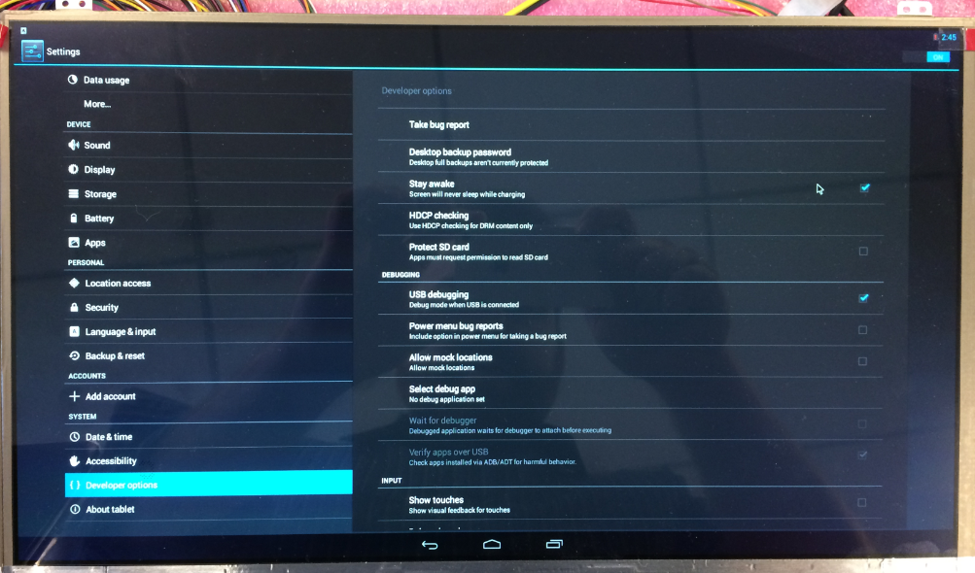

1. **Setting up SPAN**

In order to run the Robinhood application successfully on the Android platform it is necessary to setup the spanhost location. This can be done my copying a new hosts file to the kernel /etc/ folder. The hosts file will need an entry such as the following

192.168.1.14 spanhost

Where 192.168.1.14 is the location of the spanhost computer.

This file needs to be pushed to the kernel using root. The procedure can be found below:

1. Put the new hosts file in the same directory as adb.
2. Open a terminal and issue the following commands
   1. Adb devices (check to make sure an android device is connected)
   2. Adb root (start adb in root mode)
   3. Adb remount
   4. Adb push hosts /etc
3. It may be necessary to restart the operating system in order for the changes to take effect.

The system is now ready to have the Robinhood application installed.

1. **Installing Robinhood**

There are a number of ways to install the Robinhood application on Android. The first is to simply push the apk over adb. The second is through Eclipse.

If running the application through Eclipse right click on the Mai nActivity folder and select run as Android application. This will run the application without interference from the debugger. If the program is going to be debugged then right clicking and selecting debug as android device can be selected instead.